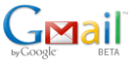
Setting Up a GMail Account for your Google Project

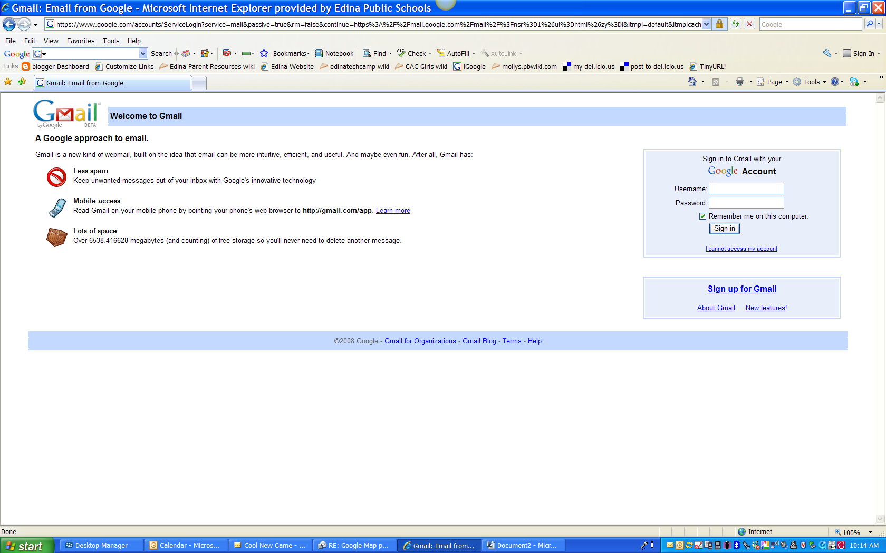
1. Go To: gmail.com and click on Sign up for Gmail

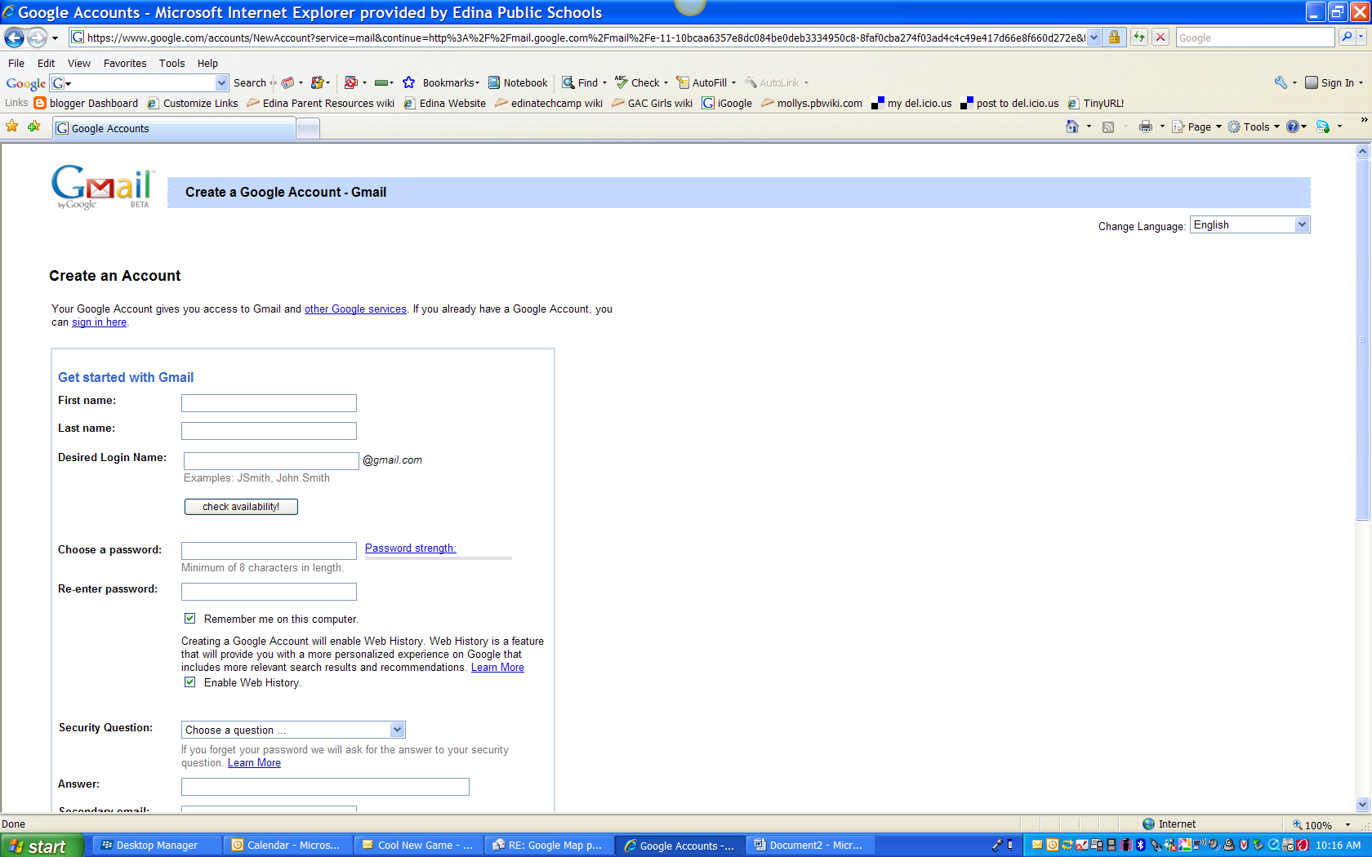
Fill out the required information with your First Name, Last Name

For Desired login in name use: lastnameclass@gmail.com
For example: schroederclass

Choose a password that your class will easily remember.

Use your Edina e-mail as your secondary e-mail

Complete the word verification and agree to the terms of Service.

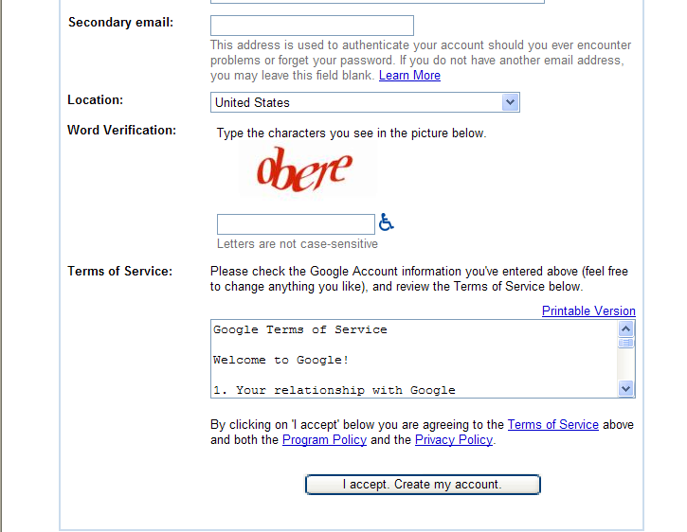

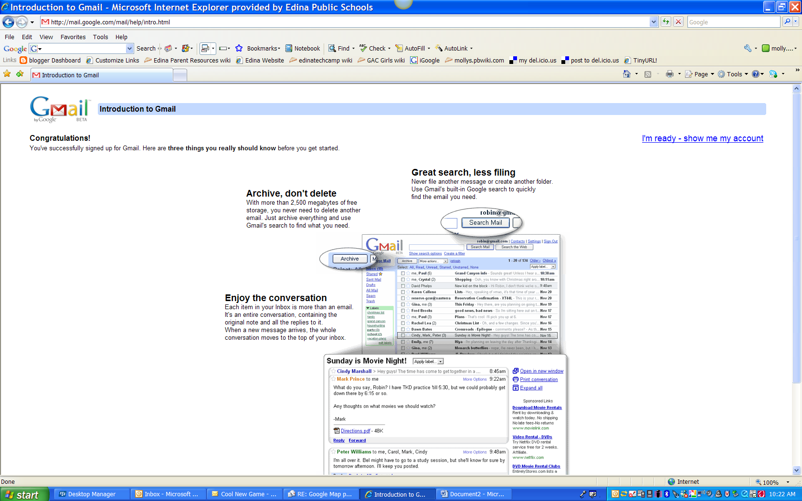
At the next screen you can read a bit about your new account and then click I’m ready-Show me my account!

Now you should be all set up with a class e-mail. You can all use this account for different Google projects that require a similar login. Make sure to change the password if you don’t want students in the account any longer.
See: How to Change My Password on the next page.
How to Change My Password for my Class GMail Account

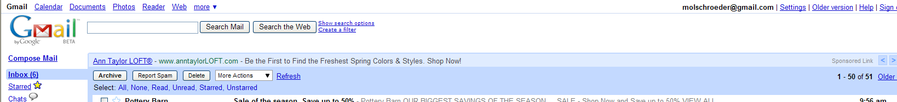
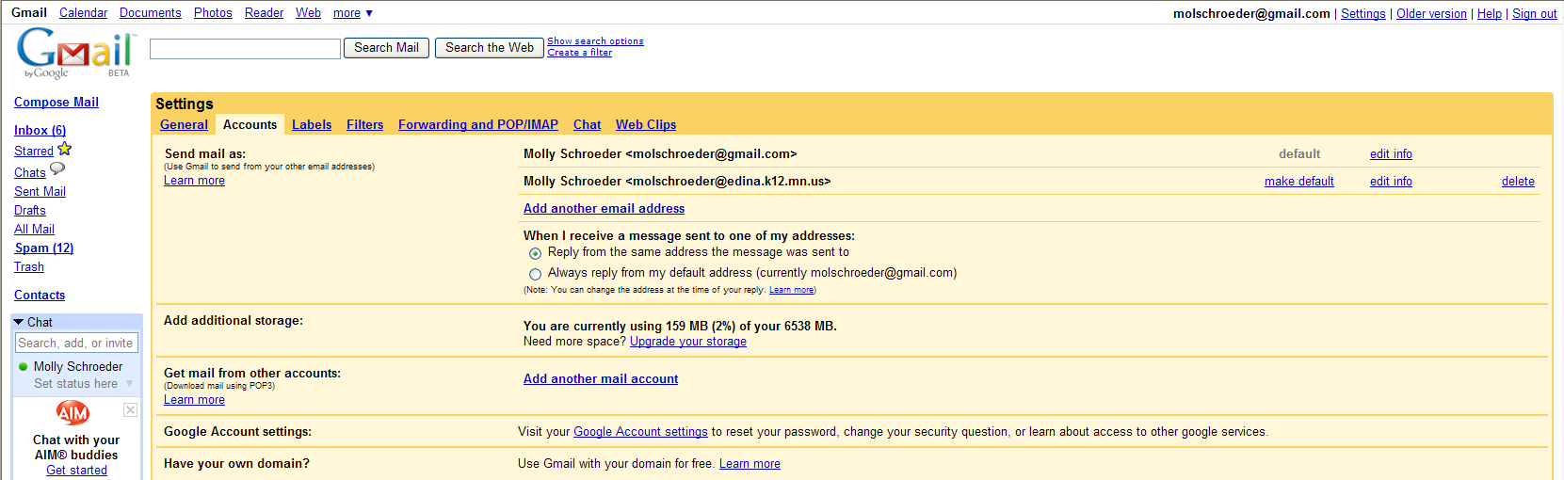
Click on Settings
Click on the Accounts Tab
Click on Google Account Settings
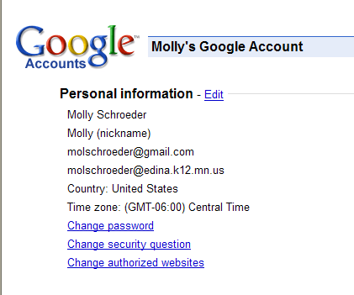

Click on Change Password

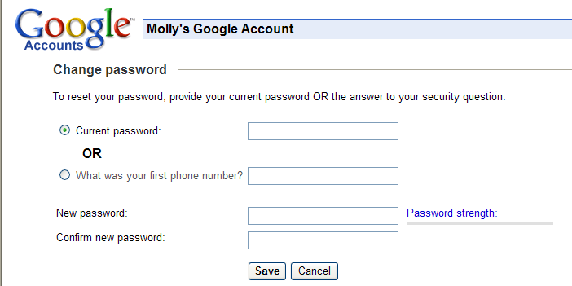
Fill in the current password, choose a new password, confirm new password and click Save

